**Task-A:**

C:\Users\safay\OneDrive\Desktop\Fig0310(a)(Moon Phobos).tif

The above is the input image. The histogram of the image is as follows:

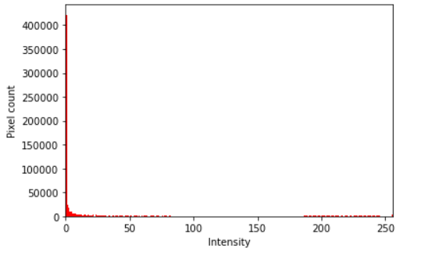

This histogram is like this because of the low contrast image. So we can see maximum pixels are concentrated in the small range. Most pixels are in the lower region and very few are in the upper region. So the image looks a lot darker.

**Task-B:**

After equalization the equalized histogram looks like:

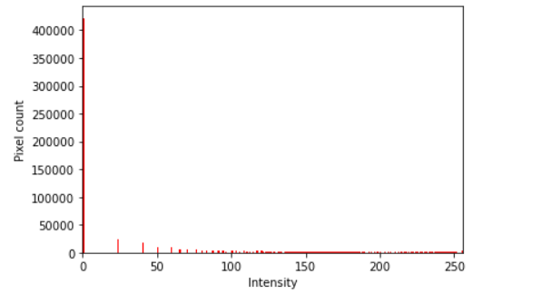

And the equalized image looks like:

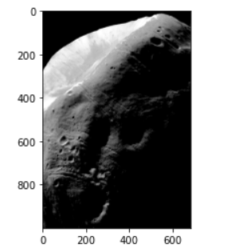

The input and equalized image looks like below side by side:

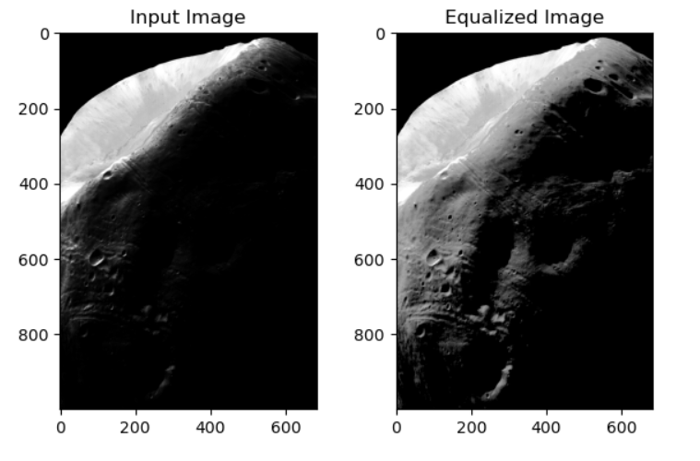

We can see the image looks a lot clear after equalization. The image is enhanced after equalization. The reason is the enhancement of the contrast. The pixels are spread out in the histogram of the equalized image.

**Task-C:**

The given function is as below:

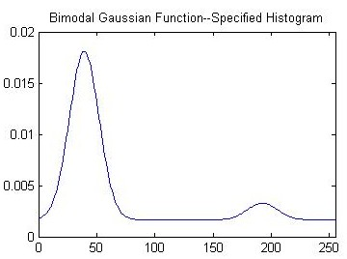

The generated function is as below:

